**Experiment no.06 Reg.no 125010005**

**Date:24th March 2024 Achyuta.M**

**Detailed Simulation of a Heat Exchanger**

**Objective**

Develop a simple process flow sheet with a shell and tube heat exchanger. Given the

configuration details of a shell and tube heat exchanger and operating conditions of inlet

streams, perform detailed simulation of the heat exchanger to determine the outlet

temperature of fluid streams, shell and tube side pressure drops and the heat duty

**Software used**

SuperPro Designer software- Continuous Heat Exchanger

**Input**

|  |  |  |
| --- | --- | --- |
| Quantity | Styrene-in | Toluene-in |
| Temperature( ͦF ) | 300 | 100 |
| Pressure(psia) | 50 | 90 |
| Molar flowrate(lb/hr) | 150000 | 125000 |
| Composition(mass fraction) | Styrene:1  Toluene:0 | Styrene:0  Toluene:1 |

**Flowsheet**

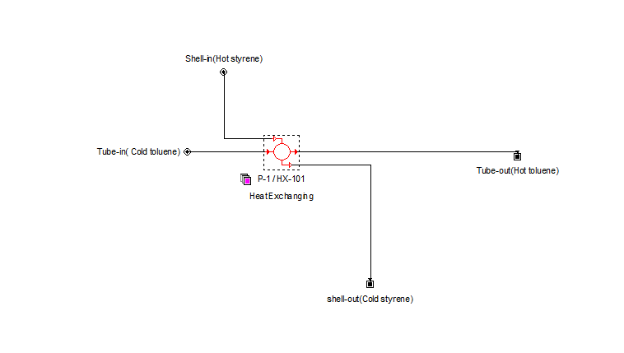**Results**

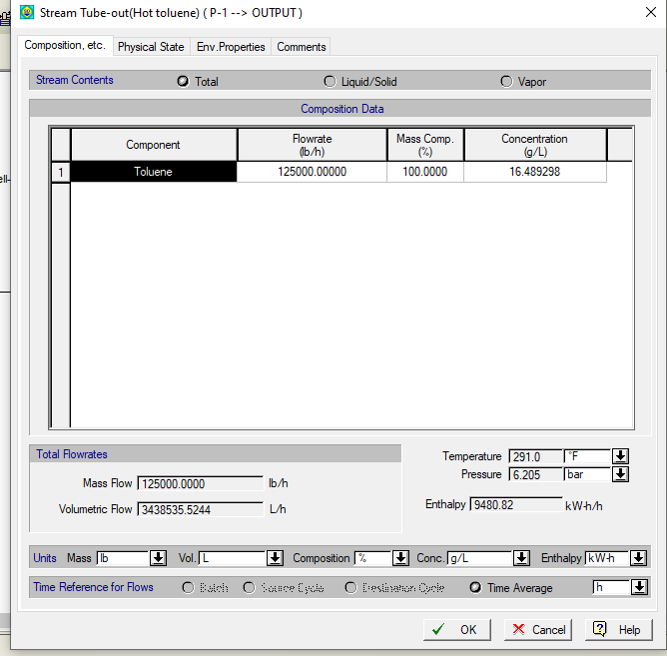

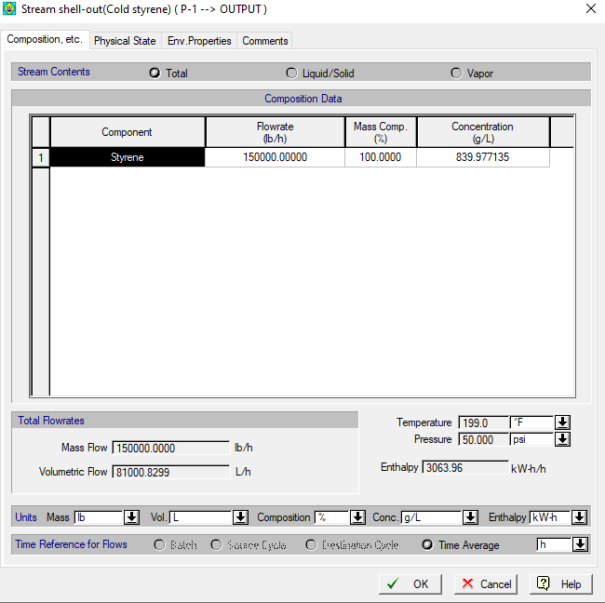

**Verification**

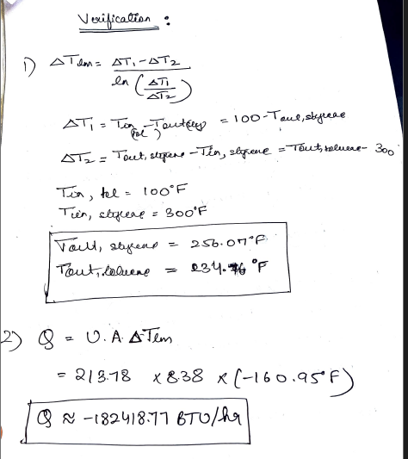

**Specific learning**

In SuperPro Designer, heat exchangers can be modelled using predefined unit operation modules specifically designed for heat transfer processes.

We can configure heat exchanger parameters such as geometry, heat transfer surface area, tube layout, and baffle arrangement based on design specifications.

The software provides analysis tools to visualize process data, including temperature profiles, pressure distributions, and heat duty distributions across the heat exchanger.